**Batch: A2. Roll No.: 16010121045**

**Experiment / assignment / tutorial No. 4**

**Grade: AA / AB / BB / BC / CC / CD /DD**

**Signature of the Staff In-charge with date**

|  |
| --- |
| **TITLE:**  Program to print patterns |

**AIM:** Program to print patterns for ‘n’ rows using nested loop **______________________________________________________________________**

**Expected OUTCOME of Experiment:**

**CO2:** Applying basic concepts of C programming for problem solving.

**_____________________________________________________________________**

**Books/ Journals/ Websites referred:**

1. Programming in C, second edition, Pradeep Dey and Manas Ghosh, Oxford University Press.
2. Programming in ANSI C, fifth edition, E Balagurusamy, Tata McGraw Hill.
3. Introduction to programming and problem solving , G. Michael Schneider ,Wiley India edition.
4. [**http://cse.iitkgp.ac.in/~rkumar/pds-vlab/**](http://cse.iitkgp.ac.in/~rkumar/pds-vlab/)

**_____________________________________________________________________**

**Problem Definition:**

The program is to print a pattern as given by the user. The program makes use of a nested loop to print a pattern of characters, numbers or alphabets.

**Example:**

Input: number of rows = 4, number of columns = 4

Output:

5

4   5

         3   4   5

    2   3   4   5

1  2   3   4   5

**Algorithm:**

**Main()**

1. Start
2. Declare n
3. Ask the user to enter the number of rows
4. Read the value of n
5. Call **patt1(n)**
6. Call **patt2(n)**
7. Call **patt3(n)**
8. Call **patt4(n)**
9. Call **patt5(n)**
10. Call **pass(n)**

**Pass(n)**

1. Start
2. Print “Pascal's triangle Pattern”
3. Declare i=0
4. **While** i<n

1. Declare k=i

2. **While** k<=n

1. Print space “ “

2. k=k+1

3. **End While**

4. Declare j=0

5. **While** j<=i

1. print **ncr(i,j)**

2. j=j+1

6. **End While**

7. i=i+1

1. **End** **While**
2. End.

**int ncr(n,r)**

1. Start
2. Declare ans=1
3. Declare i=n
4. **While** i>0

1. ans=ans*i

2. i=i-1

1. **End** **While**
2. Declare ans1=1
3. Declare i=n
4. **While** i>0

1. ans1=ans1*i

2. i=i-1

1. **End** **While**
2. Declare ans2=1
3. Declare i=n
4. **While** i>0

1. ans2=ans2*i

2. i=i-1

1. **End** **While**
2. **Return** ans/(ans1*ans 2)
3. End

**Implementation details:**

#include<stdio.h>

void patt1(int n)

{

printf("First Pattern \n\n");

for(int i=1;i<=n;i++)

{

for(int j=1;j<=i;j++)

printf("* ");

printf("\n");

}

printf("\n\n");

}

void patt2(int n)

{

printf("Second Pattern \n\n");

for(int i=n;i>0;i--)

{

for(int j=1;j<=i;j++)

printf("* ");

printf("\n");

}

printf("\n\n");

}

void patt3(int n)

{

printf("Third Pattern \n\n");

int count=1;

int ii=1;

for(int i=n;i>=1;i--)

{

for(int j=1;j<=i*2;j++)

printf(" ");

ii=n-i+1;

for(int j=1;j<=count;j++)

{

if(j>(count/2))

printf(" %d",ii--);

else

printf(" %d",ii++);

}

printf("\n");

count+=2;

ii++;

}

printf("\n\n");

}

void patt4(int n)

{

printf("Fourth Pattern \n\n");

for(int i=1;i<n;i++)

{

for(int j=i;j<n;j++)

printf(" ");

for(int j=1;j<i*2;j++)

{

printf("*");

}

printf("\n");

}

for(int i=n;i>=1;i--)

{

for(int j=1;j<i*2;j++)

{

printf("*");

}

printf("\n");

for(int j=i;j<=n;j++)

printf(" ");

}

printf("\n\n");

}

void patt5(int n)

{

printf("Fifth Pattern \n\n");

for(int i=1;i<=n;i++)

{

char k='A';

for(int j=1;j<=i;j++)

printf("%c ",k++);

printf("\n");

}

printf("\n\n");

}

int ncr(int n,int r)

{

int ans=1;

for(int i=n;i>0;i--)

ans*=i;

int ans1=1;

for(int i=r;i>0;i--)

ans1*=i;

int ans2=1;

for(int i=(n-r);i>0;i--)

ans2*=i;

return ans/(ans1*ans2);

}

void pass(int n)

{

printf("Pascal's triangle Pattern \n\n");

for(int i=0;i<n;i++)

{

for(int k=i;k<=n;k++)

printf(" ");

for(int j=0;j<=i;j++)

printf(" %3d",ncr(i,j));

printf("\n");

}

printf("\n\n");

}

int main()

{

printf("Enter a Value for n\n");

int n;

scanf("%d",&n);

patt1(n);

patt2(n);

patt3(n);

patt4(n);

patt5(n);

pass(n);

return 0;

**Output(s):**

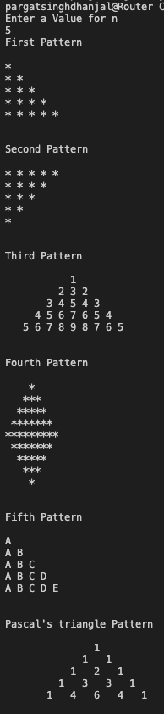

**Conclusion:**

Exp. 4 has been successfully completed and implemented.

**Post Lab Descriptive Questions:**

**Write a program to print the following:**

1

2 4

3 6 9

4 8 12 16

5 10 15 20 25

6 12 18 24 30 36

7 14 21 28 35 42 49

8 16 24 32 40 48 56 64

9 18 27 36 45 54 63 72 81

10 20 30 40 50 60 70 80 90 100

**Implementation details:**

#include<stdio.h>

int main() {

int n;

printf("Enter the number of rows: ");

scanf("%d",&n);

for(int i=1;i<=n;i++)

{

for(int j=1;j<=i;j++)

printf("%3d ",(i*j));

printf("\n");

}

printf("\n\n");

return 0;

}

**Output:**

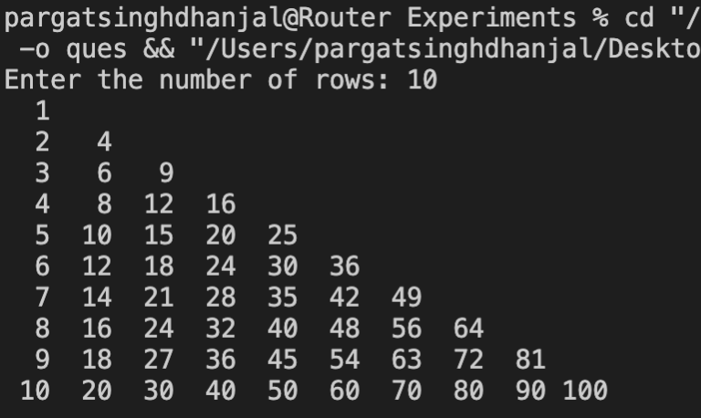

**Date: 2/12/2021 Signature of faculty in-charge**